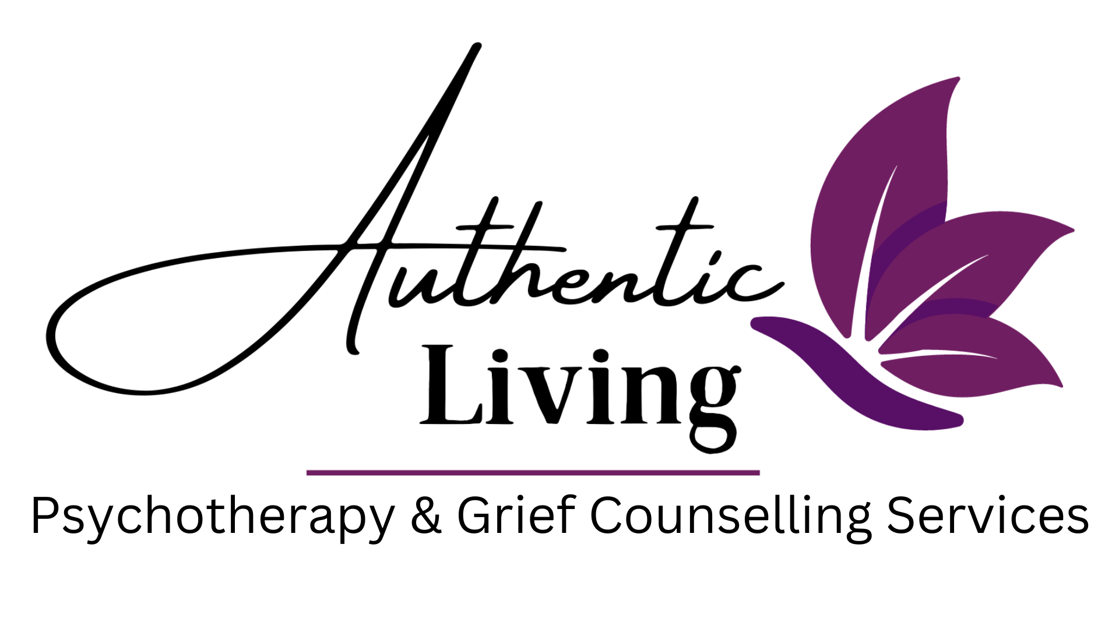
AUTHENTIC LIVING LONDON

Referral Form
Thank you for choosing Authentic Living London.
We welcome referrals from doctors, health professionals, and community partners. Patients are also welcome to self-refer by contacting us directly.

Patient Information
Full Name: ___________________________________________
Date of Birth: ____ / ____ / ______ Phone Number: ______________________________________
Email: _______________________________________________
Referring Physician / Professional (if applicable)
Name: _______________________________________________
Clinic/Practice: ________________________________________ Phone Number: ___________________________
Fax: _________________________________________________ Email: ___________________________________________

Reason for Referral (please check all that apply)
☐ Anxiety ☐ ADHD/ASD ☐ Depression ☐ Grief & Loss ☐ Trauma ☐ PTSD/C-PTSD ☐ Relationship/Couples Concerns ☐ Identity or Self-Esteem Concerns ☐ Anger Management ☐ Other: ___________________________________

Additional Information
(Please include relevant medical, psychosocial, or safety concerns)
_________________________________________________________________________________________________________

Preferred Contact Method for Patient
☐ Phone ☐ Email ☐ Either

Consent to Referral
I confirm that the patient has been informed of this referral and consents to be contacted by Authentic Living London.
Referrer Signature: ______________________________________________________ Date: ____ / ____ / ______

Submission
Please fax completed forms to: 519-279-0164
Or email to: info@authenticlivinglondon.com
For questions, please call us at: 226-224-0301
We will do our absolute best to contact all referrals within 1 business day.
Please note: We do not provide crisis services.

